Week 1 Lab Task
Lab Setup & Information Gathering
NIAI NAVTTC — Certified Ethical Hacker (CEH) Course
⚠ Important: All tasks must be performed only in your isolated virtual lab environment. Never test on real networks or systems without explicit written permission.

Task: Hands-on practice on setting up your cybersecurity lab environment and performing basic information gathering.

▶ Install VirtualBox
Download VirtualBox (free) from virtualbox.org and install it on your laptop.
- Virtual Box Installed
▶ Install Kali Linux VM
Download the Kali Linux .ova file from kali.org.
In VirtualBox: File → Import Appliance → select the .ova file.
Start the VM. Default credentials: username = kali, password = kali
- Kali Linux Installed
▶ Take a Snapshot
Once Kali is running, go to Machine → Take Snapshot.
Name it 'Clean Install'. This is your safe restore point if something breaks.
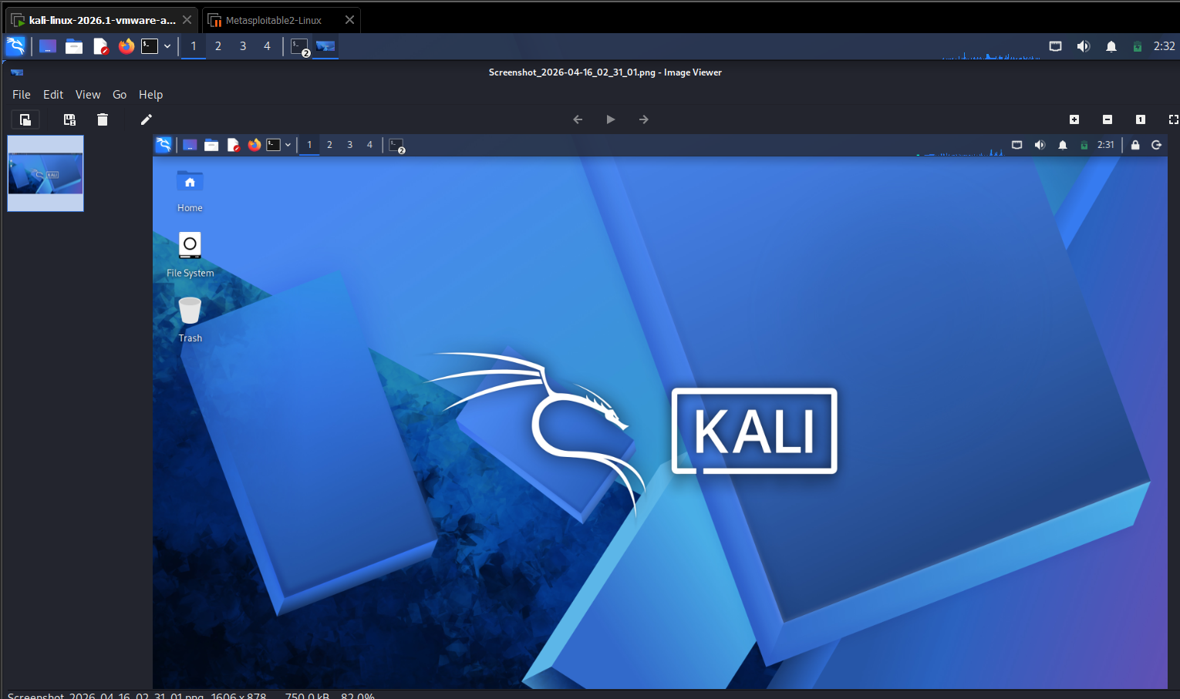
▶ Practice Basic Linux Commands
ls # List files in current directory
pwd # Print current working directory
cd /home # Change directory
ifconfig # Show network interfaces and IP addresses
ping google.com # Test network connectivity
whoami # Show current logged-in user

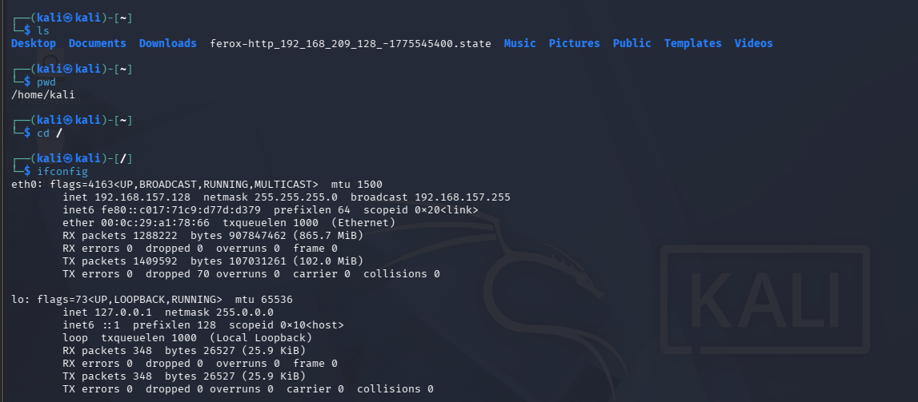

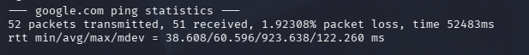
▶ Basic Information Gathering
Open a terminal in Kali and run the following:
whois google.com # See domain registration details
nslookup google.com # DNS lookup — find the IP address
ping google.com # Basic connectivity check

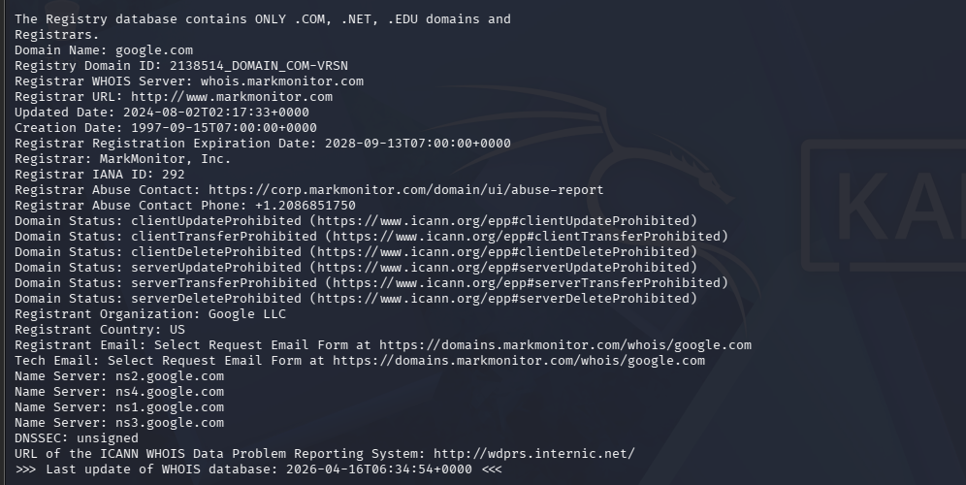

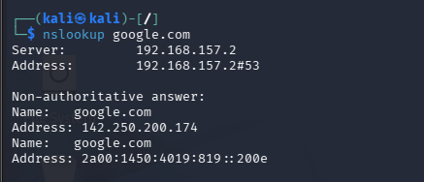

🎯 Goal: Your lab environment is fully set up, Kali Linux is running, and you can execute basic Linux and information-gathering commands successfully.
You can upload Your Lab manual that you created for Week One submition

